**West Coast Collaborative**

**Test 2 2016**

**Calculator Free Section**

**Name: __________________________ Score: _____ / 31**

**Section 1 is worth 50% of your final test mark.**

**No calculators or notes are to be used.**

**Access to approved Sample Mathematics Specialist formulae sheet**

**is permitted. Time limit = 35 minutes.**

1. **[5 marks: 2, 3]**

The functions $f(x)$ and $g(x)$ are given by $f\left(x\right)= \sqrt{2x+4}$ and $g\left(x\right)= \frac{1}{2}x^{2}-4$.

1. Determine and simplify $f(g\left(x\right))$.
2. State the largest possible domain for *g(x)*  so that $f∘g\left(x\right)$ is a function, and the range of $f∘g\left(x\right)$.
3. **[3 marks: 2, 1]**

The graph of $y=f(x)$ is shown.

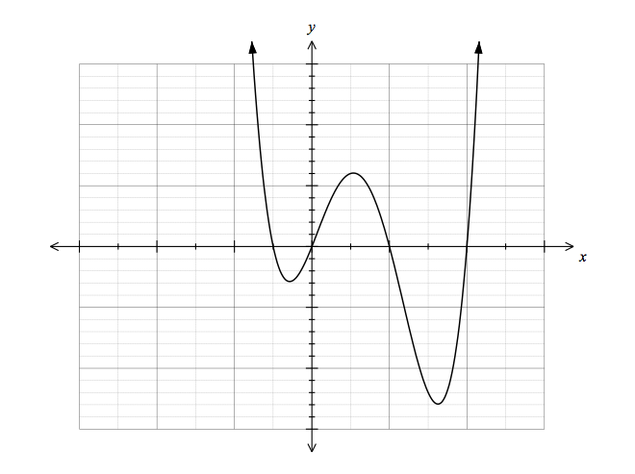

1. Draw the graph of $y=f(\left|x\right|)$ on the same axes.
2. Briefly explain how to obtain the graph of $y=|f\left(x\right)|$ from $y=f(x)$.
3. **[1, 2, 2, 4 = 9 marks]**

Given  and  , determine:

**a)** f(0)

**b)** fg(3)

**c)** Explain why fg(x) is a function for the natural domain of g(x) whereas gf(x) is not a function for the natural domain of f(x).

**d)** Find the largest possible domain for f(x) so that the inverse of f(x) is a function. Using this

domain for f(x), state the equation of  and state the domain and range of .

1. **[2, 3, 1 = 6 marks]**

**a)** Sketch the function $f\left(x\right)=2-\sqrt{x+1}$ on the axes below

**b)** Sketch the function $\frac{1}{f(x)}$ also on the axes below, and label each graph clearly

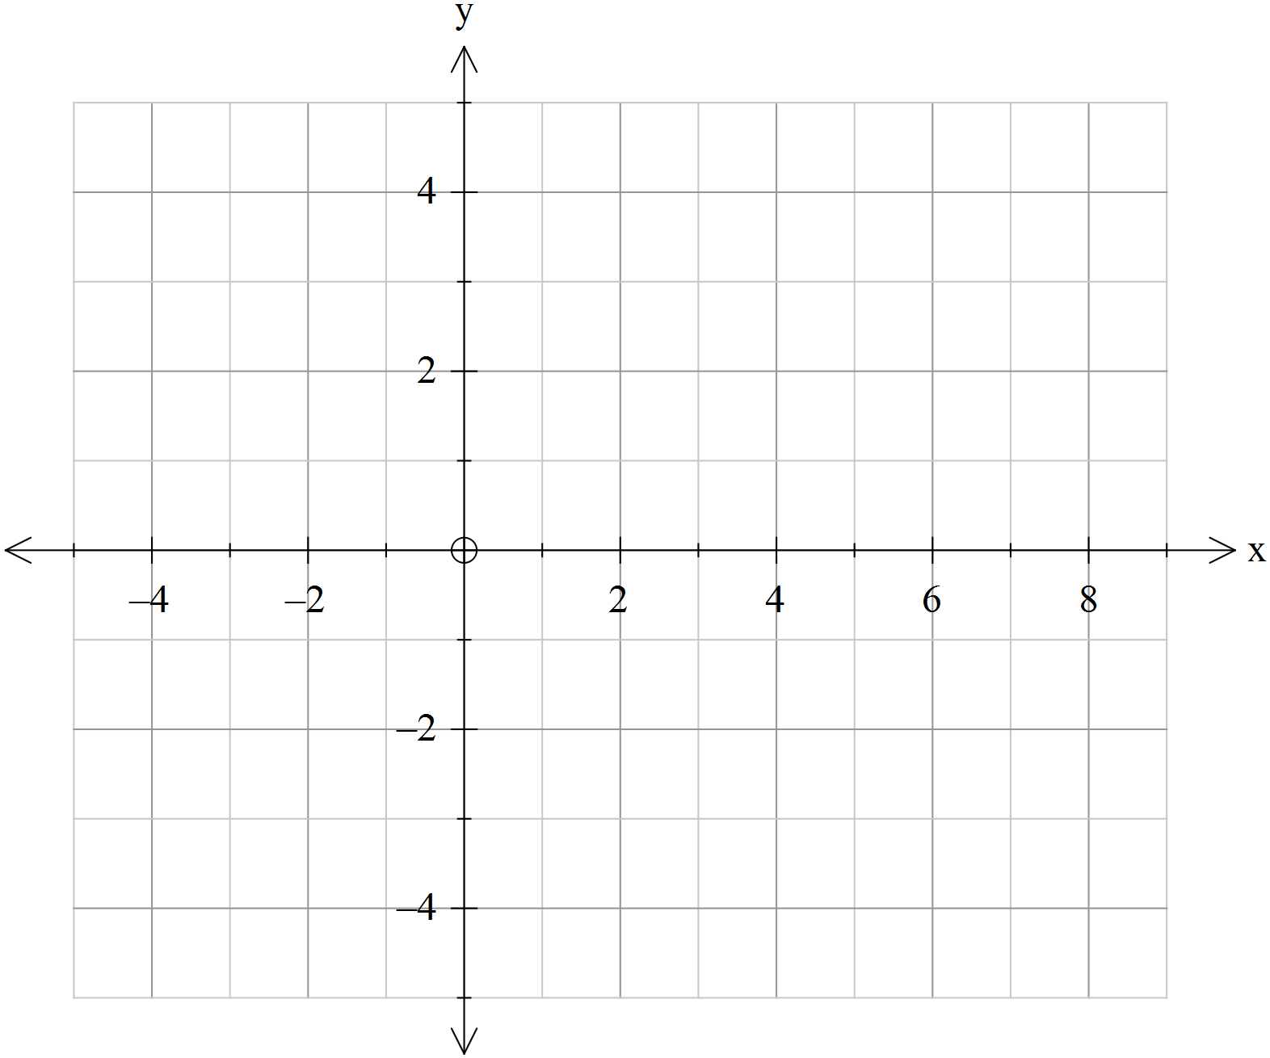

**c)** Use your sketch to state the domain of $\frac{1}{f(x)}$

1. **[8 marks]**

Sketch the following curve on the axes provided, showing any working out in the space provided. Consider important features such as intercepts, asymptotes, turning points, behaviour of the function approaching asymptotes and behaviour of the function for very large and very small values of x.

*y*

*x*

$$y= \frac{3(x-2)}{x(x+6)}$$

**West Coast Collaborative**

**Test 2 2016**

**Calculator Section**

**Name: _______________________ Score: _____ / 28**

**Section 2 is worth 50% of your final test mark.**

**Calculators allowed and 1 page of A4 notes, writing on both sides.**

**Access to approved Sample Mathematics Specialist formulae sheet**

**is permitted. Time limit = 25 minutes.**

**6. [6 marks]**

Use an algebraic method to solve: |3*x*+3 | ≥ |*x* – 2 |

**7. [2, 2, 2, 3 = 9 marks]**

a) Solve , giving your solution(s) in terms of .

b) The graphs of  and  are shown below.



(i) Solve .

(ii) Solve 

(iii) Given that the solution to  is -5 ≤ *x*, determine all possible values for  and .

**8. [6 marks]**

Rewrite $\left|2x-5\right|+\left|x+3\right|=y$ as a piecewise function.

**9. [3, 2, 2 = 7 marks]**

**a)** For each graph below that shows a function, on the same axes sketch the inverse function. For those that do not show a function, clearly indicate which graph(s) and briefly give your reasoning in the space below the graph.



**b) $f\left(x\right)=\sqrt{x}-3$**  and $g\left(x\right)={(x+2)}^{2}$

**i)** Obtain an expression for $fg(x)$

**ii)** Draw $fg(x)$ on the axes below

